**Zomato Objective and Subjective Questions**

**Objective Questions:**

1 What is the total number of tables present in the data?

Ans: 2

2.What is the total number of attributes present in the data?

Ans: 22

3.How many categorical columns are there in the data?

Ans: 15

**SHEET - RAW DATA:**

1. Restaurant
2. CountryCode
3. City
4. Address
5. Locality
6. LocalityDetail
7. Cuisines
8. Currency
9. TableBooking
10. OnlineDelivery
11. DeliveringNow
12. OrderMenu
13. OpeningDate

**SHEET - COUNTRY DESCRIPTION:**  
14. CountryCode  
15. Country

4.Ensure that the data used for further analysis is cleaned.

Ans:

**MISSING VALUES**

1. **Cuisines:**

There were 9 missing values in Cuisines.

How I have figured it out:

* Find and select
* Go to special
* Blanks

All blank cells got highlighted with green colour. Applied ‘filter by colour’ on ‘Cuisines’ to check the blank values.

Reason: I observed all the 9 missing values belong to country code – 216. So, Created two pivot tables.

Table 2:

Rows- Cuisines

Columns - Country code

Values- Avg. Rating

Output – Blank restaurant – 3.9

Table 1:

Rows- Country code

Values - distinct count of restaurant id & average rating

Output: Restaurant count- 434 (2nd highest) &

Avg. Rating-4.0

1. Average of all restaurant is approximately equals to average of restaurants with blank cuisines. So, removing these restaurants with blank cuisines will not affect the overall rating of country.
2. 216 country code has large no. of restaurant, so removing 9 restaurants from this large no. will not affect the whole dataset

On the basis of above observation, **deleted the 9 rows**.

**INCONSISTENT VALUES**

1. **Restaurant ID**

* I noticed that some restaurant IDs had fewer than 8 characters.
* To check, I used a formula to find the maximum length, which was 8.
* Then, I used conditional formatting to highlight IDs shorter than 8 characters.
* Formula used: =LEN(A1)<8
* **Fix:** I applied a custom format “00000000” so all IDs have 8 digits, adding leading zeroes where needed.

1. **Extra Spaces**

* I suspected that some text fields had unwanted spaces at the start or end.
* To find them, I used conditional formatting with this formula: =LEN(A1)<>LEN(TRIM(A1))
* It showed that “Address,” “Locality,” and “LocalityVerbose” had extra spaces.
* **Fix:** I used the TRIM function to remove all leading and trailing spaces and made the data clean

5.Using the LookUp functions, fill up the countries in the original data using the country code.

Ans:

* Formula: =XLOOKUP(C2,'country & dollar value'!A:A,'country & dollar value'!B:B)

|  |
| --- |
| **Country** |
| India |
| India |
| India |
| India |

6.Create a table to represent the number of restaurants opened in each country.

Ans:

|  |  |
| --- | --- |
| **Country** | **Number of Restaurants** |
| Australia | 24 |
| Brazil | 60 |
| Canada | 4 |
| India | 8652 |
| Indonesia | 21 |
| New Zealand | 40 |
| Philippines | 22 |
| Qatar | 20 |
| Singapore | 20 |
| South Africa | 60 |
| Sri Lanka | 20 |
| Turkey | 34 |
| United Arab Emirates | 60 |
| United Kingdom | 80 |
| United States of America | 434 |
| Grand Total | 9551 |

7. Also, the management wants to look at the number of restaurants opened each year, so provide them with something here.

Ans:

|  |  |
| --- | --- |
| **Year** | **Number of Restaurants** |
| 2010 | 1080 |
| 2011 | 1098 |
| 2012 | 1022 |
| 2013 | 1061 |
| 2014 | 1051 |
| 2015 | 1024 |
| 2016 | 1027 |
| 2017 | 1086 |
| 2018 | 1102 |
| Grand Total | 9551 |

8.What is the total number of restaurants in India in the price range of 4?

Ans:

|  |  |
| --- | --- |
| Price_range | 4 |
| Country | india |

|  |  |
| --- | --- |
| Number of Restaurants | 388 |

9. What is the average number of votes for the restaurants in each country?

Ans:

|  |  |
| --- | --- |
| **Country & Restaurants** | **Average of Votes** |
| Australia | 111 |
| Brazil | 20 |
| Canada | 103 |
| India | 137 |
| Indonesia | 772 |
| New Zealand | 243 |
| Philippines | 407 |
| Qatar | 164 |
| Singapore | 32 |
| South Africa | 315 |
| Sri Lanka | 146 |
| Turkey | 431 |
| United Arab Emirates | 494 |
| United Kingdom | 205 |
| United States of America | 428 |
| Grand Total | 157 |

10.Calculate the average rating for all restaurants with a price range less than 4 and online delivery.

Ans:

* Formula: AVERAGE(IF((Table2[Price_range] < 4)*(Table2[Has_Online_delivery]="Yes"),Table2[Rating]))
* Result: 3.27

11.Using conditional formatting, highlight the rows of restaurants in the suggested countries or cities.

Ans: In the subjective questions 1 and 2, we can observe the name and method utilized to weed out the names of the recommended nations and cities, respectively. Next, I highlighted the names of restaurants within that proposed city using the city's name (found in column F). The conditional formatting formula is shown below, and the excel sheet titled "Restaurants in suggested Cities" displays the names of each restaurant.

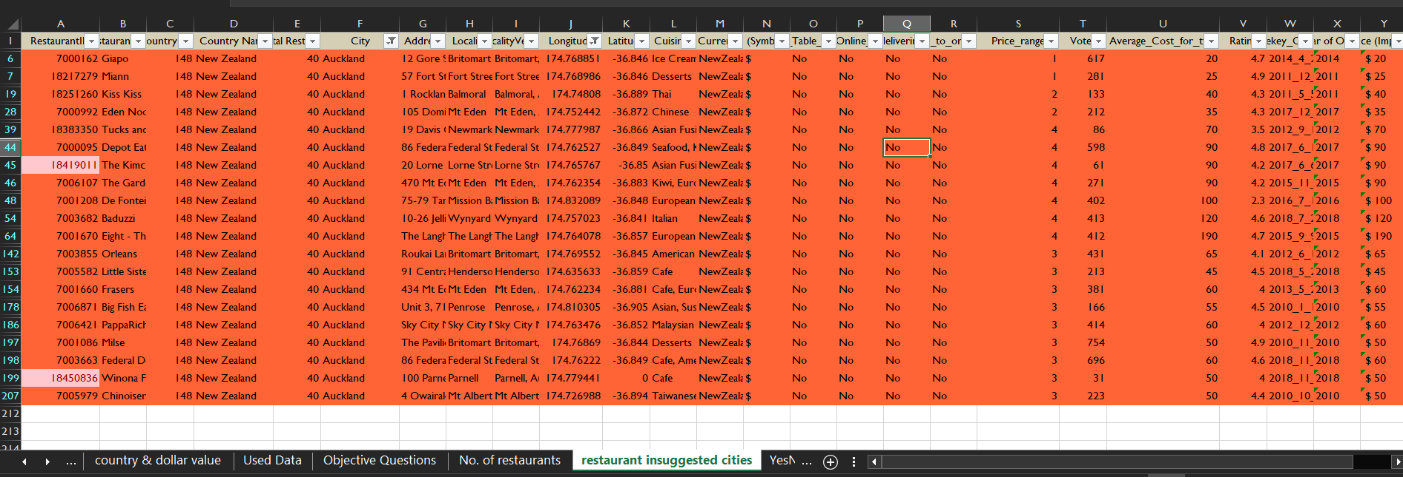

12.Create a new customized price column with the currency symbol and the Average_cost_for_two value.

Ans:

|  |
| --- |
| **Average_Cost_for_two2** |
| ₹ 300 |

13.How can you create an array formula in Excel or Google Sheets to count restaurants that do not offer online delivery, are in the lowest price range, and have an average cost for two less than or equal to 250 Indian Rupees?

Ans:

* Formula: =COUNTIFS(Table2[Has_Online_delivery],"No",Table2[Price_range], MIN(Table2[Price_range]),Table2[Average_Cost_for_two],"<=250")
* Result: 1694

**Subjective Questions:**

1. Suggest countries for opening new restaurants with less competition. Which visualization/technique will you use?

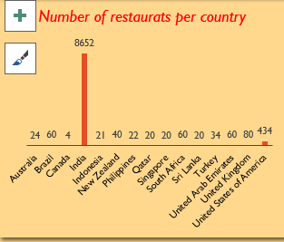Ans:

* India and the USA have been excluded due to a high number of restaurants and market saturation.
* A higher number of restaurants will create more competition resulting in a heavily cluttered market. So, I have excluded India & USA.

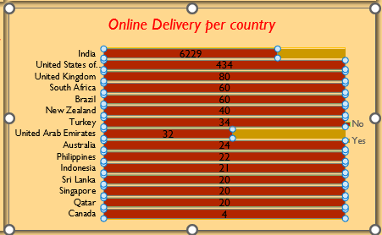

* United Arab Emirates is excluded due to the existing online delivery services.
* Opening new restaurants in UAE means facing competition from existing players. Therefore, we can exclude UAE also

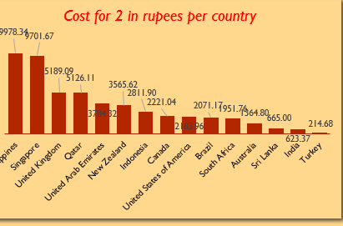

* Turkey and Sri Lanka are excluded due to exceptionally low costs. Brazil and the United Kingdom are excluded due to very bad ratings.
* From the chart it is clearly visible that Turkey & Sri Lanka has the lowest cost for 2 in rupees.

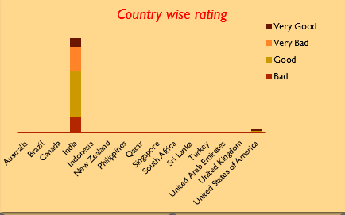

* Australia, Canada, and Singapore are recommended due to the extremely low number of restaurants with very good ratings.

2.Suggest suitable states and cities in the recommended countries for opening restaurants.

ANS : Cities in green colour have ratings of more than 4. If we open restaurants in these cities, we will face tough competition from existing restaurants of these cities.

• Cities in yellow colour have a rating of greater than 3.5 but less than 4. From this we can consider that these cities have scope of opening new restaurants.

• Cities in red colour have a rating of less than 3.5. From this we can assume that these cities are not so restaurant friendly.

We will do more analysis on cities in yellow colour range.

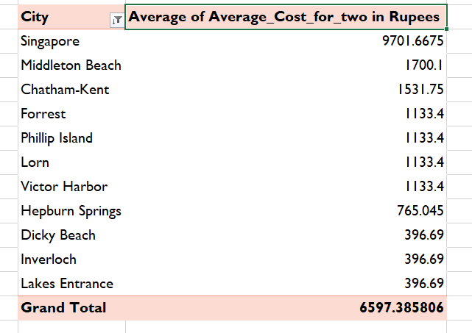• rom the chart it is clearly visible that Singapore, Middleton Beach & Chatham-Kent are 3 cities where cost for 2 in rupees is maximum.

• Because of the exceptionally low cost, achieving break-even might pose a challenge.

• So, we will select top 3 cities Singapore, Middleton Beach & Chatham-Kent.

3.What is the current quality of ratings for restaurants in the suggested countries?

Ans: Rating Quality in Australia

* 26% restaurants have a rating of more than 4
* 52% restaurants have a rating between 3.5 & 4
* 22% restaurants have a rating less than 3 .5

|  |  |
| --- | --- |
| Australia | |
| City | Average of Rating |
| Beechworth | 4.6 |
| Tanunda | 4.4 |
| Palm Cove | 4.4 |
| Trentham East | 4.1 |
| East Ballina | 4.1 |
| Huskisson | 4.1 |
| Lakes Entrance | 3.8 |
| Hepburn Springs | 3.8 |
| Middleton Beach | 3.8 |
| Forrest | 3.7 |
| Inverloch | 3.7 |
| Phillip Island | 3.7 |
| Victor Harbor | 3.6 |
| Dicky Beach | 3.6 |
| Lorn | 3.6 |
| Flaxton | 3.5 |
| Macedon | 3.5 |
| Armidale | 3.5 |
| Penola | 3.4 |
| Balingup | 3.2 |
| Mayfield | 2.9 |
| Paynesville | 2.6 |
| Montville | 2.4 |

**Therefore, we can say that most restaurants fall in the mid category of 3.5 & 4.**

**Least number of restaurants falls in the bad category of less than 3.5.**

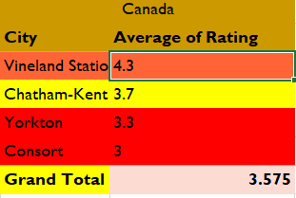**Rating Quality in Canada**

* **25% restaurants have a rating of more than 4**
* **25% restaurants have a rating between 3.5 & 4**

**50% restaurants have a rating of less than 3**

**Rating Quality in Singapore**

* **All the restaurants have an average rating between 3.5 & 4**

1. What is the current expenditure on food in the suggested countries?

Ans: Singapore has the highest expenditure, followed by Canada and Australia.

* In Canada expenditure is comparatively lower.
* 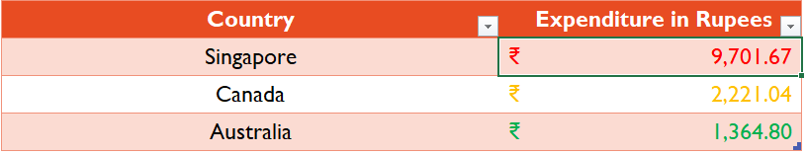In Australia expenditure is least among suggested countries.
* High expenditure encourages culinary innovation, menu variety, and quality, enhancing customer satisfaction and reputation.
* Creativity & Innovation: High expenditure on food encourages chefs to experiment with unique flavours, presentation, and culinary techniques. Creative dishes can become signature items that draw customers specifically to your restaurant.
* Menu Variety: A larger food budget allows you to offer a diverse menu with a wider range of dishes. Variety attracts different customer preferences and dietary needs, ensuring that there’s something for everyone.
* Quality & Reputation: Spending on high-quality ingredients can enhance the taste and overall dining experience for customers. Word-of-mouth recommendations and online reviews often highlight exceptional food quality.
* Customer Satisfaction: For prioritizing food quality customers are more likely to leave satisfied and return for future visits. Repeat business is crucial for long-term success.

5.Suggest restaurants from the recommended states that are our biggest competitors and those that are rated in the lower brackets, i.e., 1-2 or 2-3.

Ans:  **Approach**

**Recognizing Key Competitors**  
Analyzing market leaders helps in understanding their strategies, strengths, and competitive edge. Identifying top competitors provides valuable insights into effective practices.

**Spotting Low-Rated Restaurants**  
• Identifying common flaws and areas needing improvement becomes easier by analyzing low-rated establishments.  
• Helps uncover customer dislikes, aiding in avoiding the same pitfalls.  
• Reveals market opportunities by highlighting gaps and unmet customer expectations.

**Criteria for Top Competitors:**

1. Restaurant rating is 4 or above
2. Average cost for two is less than ₹1600
3. More than 150 user votes

**Visualization - Pivot Table:**  
Display restaurant names alongside their respective countries and states to highlight the leading competitors.

Singapore City:

* 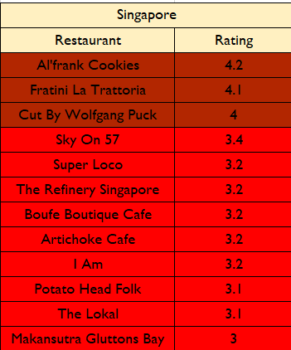Biggest competitors: Al'frank Cookies, Fratini

La Trattoria, Cut by Wolfgang Puck.

* Lower-rated restaurants: Potato Head Folk,
* The Lokal, Makansutra Gluttons Bay.

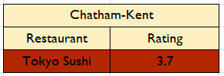 Chatham-Kent City:

* Biggest competitor: Tokyo Sushi.

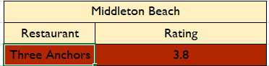Middleton Beach City:

* Biggest competitor: Three Anchors.

**Insights and Recommendations**

**A. Competitive Overview:**  
Bridge Road Brewers in Beechworth, along with Fish Streat and Flip Burger in Jakarta, emerge as key competitors thanks to their strong ratings and high voter engagement. Studying their business models and customer approach can offer valuable insights into effective strategies.

**B. Areas for Improvement:**  
Restaurants like Vadakkan Pepper in Sharjah and Sangeetha Vegetarian Restaurant in Abu Dhabi, which have lower ratings, may highlight issues related to service quality, customer satisfaction, or overall experience. Observing these gaps can help in avoiding similar pitfalls and improving offerings.

6.Which cuisines should new restaurants focus on for better feedback? Does the choice of cuisine affect restaurant ratings?

Ans:

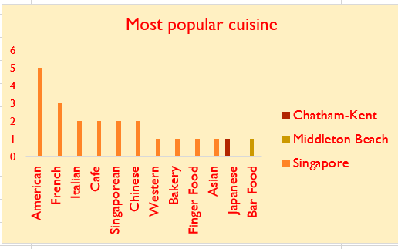**Singapore:**

In Singapore top 3 common cuisines are American, French, Italian

**Middleton Beach:**

In Middleton Beach City most common

cuisine is Bar Food.

**Chatham-Kent:**

In Chatham-Kent City most common cuisine is Japanese.

* Analysis indicates no strong correlation between cuisine and rating.

My recommendation for cuisine

* Singapore: American & French
* Middleton Beach : Bar Food
* Chatham-Kent : Japanese

In my analysis did not find a strong relation between cuisine & rating. I have found that most common cuisine does not have a high rating in most cases & local cuisines some places got a high rating but there are many cases where local cuisines got low rating also. Correlation between number of restaurants & average rating is -0.24.

While doing regression analysis I have found that value of R Square is 0.57 which is not very close to 0.

Reference : Cuisine vs Rating sheet of excel file.

Considering the above mentioned insights I can say that there is not a very strong correlation between choice of cuisine & rating.

1. According to our current data, should we go for online delivery and table booking? Does that affect the customer’s ratings?

Ans: Online delivery and table booking increase customer ratings, so they are recommended.

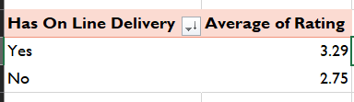

From the pivot table it is clearly visible that with online delivery higher rating has been achieved.

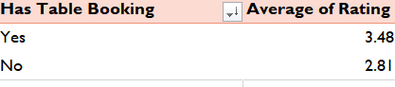

From the pivot table it is clearly visible that with table booking rating has been increased

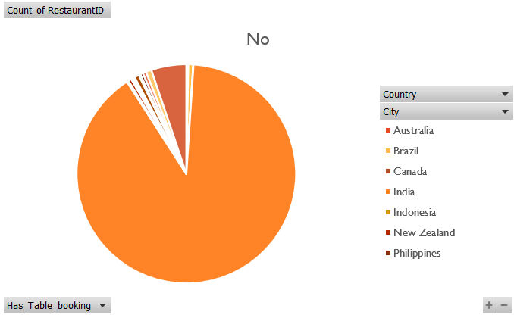

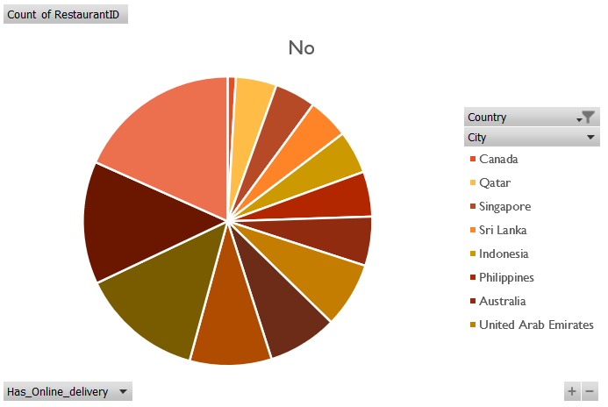

Therefore, my suggestion will go for online delivery & table booking. Yes, online delivery & table booking affects rating. It increases rating.

8.Should the team keep the rate of cuisines higher? Will that affect the feedback? According to our data, are the rates of cuisines and ratings correlated?

* Ans: The correlation between cuisine price and rating is 0.33, with an R-squared value of 0.10, indicating no strong correlation. Therefore, higher rates do not significantly affect feedback.

**Approach:**

* A scatter plot was utilized to highlight the general pattern and trajectory of the data, making it easier to observe any linear associations. Additionally, I performed a correlation analysis and created a pivot table to explore how cuisine ratings and average dining costs for two people vary across different countries.

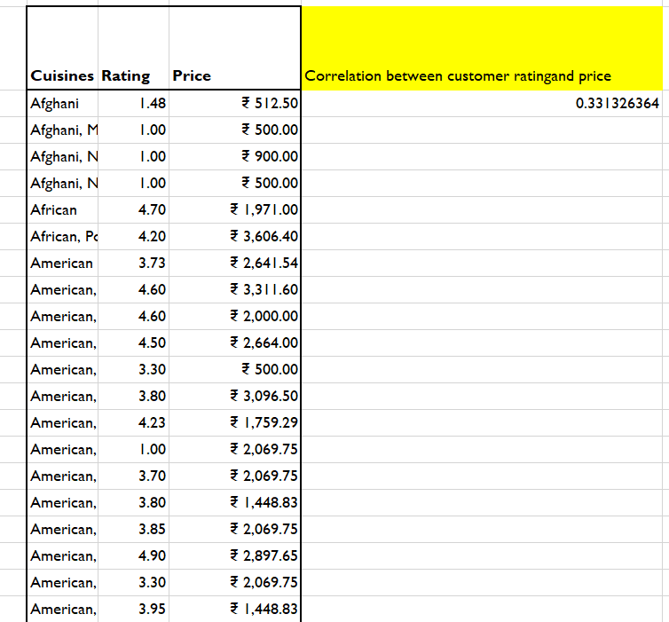

**[where=CORREL(Table2[Average_Cost_for_two in Rupees],Table2[Rating])]**

**Insights:  
The scatter plot indicates a general upward pattern, suggesting a potential positive relationship between cuisine prices and ratings. This means that, in many cases, higher-priced cuisines tend to receive better ratings.**

**Recommendation:  
However, this observed trend does not imply that prices should be increased across all cuisines and countries to improve ratings. It’s important to review scatter plots by country and consider raising prices only where it's appropriate and allowed by local regulations.**

9.What is the distribution of the number of restaurants of different price ranges in all the countries?

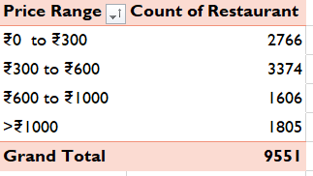Ans: Most restaurants fall in the price range of ₹300 to ₹600, while the least number are in the ₹600 to ₹1000 range.

I converted average cost in Indian Rupees. Then I created 4 buckets of ₹0 to ₹300, ₹300 to ₹600, ₹600 to ₹1000 & >₹1000. The I created a pivot keeping price range in row column & count of restaurants in value column.

Most number of restaurants fall under ₹300 to ₹600 bucket whereas least number of restaurants fall under ₹600 to ₹1000 bucket

1. Explain your approach in brief for suggesting countries/cities in order to open new restaurants

* Ans: The approach involves excluding countries with high competition (India, USA, UAE) or low potential (Turkey, Sri Lanka, Brazil, UK). Cities with ratings between 3.5 and 4 and high expenditure on food are preferred. Online delivery and table booking are recommended to increase customer ratings.

1.Exclude India & USA as these two countries have high number of restaurants already available.

2.United Arab Emirates is a country where Online delivery is already available.

Opening new restaurants in UAE means facing competition from existing players.Therefore, we can exclude UAE also

3.Turkey & Sri Lanka has the lowest cost for 2 in dollar. Because of the exceptionally low cost, achieving break-even might pose a challenge.So, we will exclude Turkey & Sri Lanka.

4.Brazil & United Kingdom are two countries where people have given Very Bad rating. Because of this we can consider people in these two countries are not so restaurant friendly. Therefore, we can exclude Brazil & United Kingdom.

5.Australia, Canada, Singapore are three countries where number of restaurants with very good rating is extremely low. Rest all the countries have high number of restaurants with very good ratings that creates a highly cluttered market. From this insight we can consider that Australia, Canada & Singapore are three countries where there is demand for restaurants with very good rating. So, we will exclude Turkey & Sri Lanka.

6.Countries that I will recommend are Canada, Australia, Singapore

7.If we open restaurants in cities having ratings of 4 or more than 4, we must face tough competition from existing restaurants of these cities. For cities having a rating of less than 3.5 we can assume that these cities are not so restaurant friendly. For cities having a rating of greater than 3.5 but less than 4 we can consider that these cities have the scope of opening new restaurants.

8.High expenditure on food encourages chefs to experiment with unique flavours, presentation, and culinary techniques. Creative dishes can become signature items that draw customers specifically to your restaurant. A larger food budget allows you to offer a diverse menu with a wider range of dishes. Variety attracts different customer preferences and dietary needs, ensuring that there’s something for everyone.

9.Spending on high-quality ingredients can enhance the taste and overall dining experience for customers. Word-of-mouth recommendations and online reviews often highlight exceptional food quality.

For prioritizing food quality customers are more likely to leave satisfied and return for future visits. Repeat business is crucial for long-term success.

10.Providing online delivery & table booking facility will increase customer rating significantly.